|  |
| --- |
| **UCSI COLLEGE** |
|  |
| **ACADEMIC YEAR 2023/2024** |



**Subject : DIT2144 Database Application**

**Semester : September 2023**

**Programme : Diploma in Information Technology & Diploma in Information System**

**ASSIGNMENT COVER PAGE**

Course Details

Subject Code : DIT2154

Subject Title :Web Design

Trimester : September 2023

Title of assignment : Web Design Part 1,2,3

Lecturer’s Name : Lee Chiw Yi

*Important Note : Submission of assignments is the responsibility of the students.*

***Failure to reference may result in a zero mark***

Student’s Details

1. Name and ID : Wong Re Yao 2023000072

2. Name and ID : Caleb Chan Kyle 2023000029

3. Name and ID : Chung Shu Wen 2022000477

4. Name and ID : Kok Zhen Hui 2022000499

5. Name and ID : Liew Zhi Jian 2022000038

**Part 1**

**TABLE OF CONTENT**

|  |  |
| --- | --- |
| **Page** | **Content** |
| 1 | Cover Page |
| 2 | Table of Content |
| 3 | Background |
| 4 - 5 | Compare and Contrast |
| 6 | Functions |
| 7 | Targeted Audience |
| 8 - 9 | Member Introduction |
| 10 | References |

**Abstract**

A business/marketing website called CEPAT was created to appeal to a variety of customers, including Value Shoppers, Families, Hobbyists, Local Shoppers, Entrepreneurs, and Fashion Lovers. The platform includes necessary features like Customer Support, an intuitive Home Page, Language Swap, Search and Filter choices, a Cart Page for easy buying, and fascinating Content Pages. By offering a variety of goods, assisting business owners in increasing sales, and keeping consumers up to speed with the newest technology and gadgets, CEPAT responds to market requirements. Our website aspires to develop a thriving online market that accommodates the various tastes and requirements of customers.



Cepat Logo

**BACKGROUND**

The Website we have chosen for out project is Shopee. In the ever-evolving landscape of e-commerce, one company has been making big waves in Southeast Asia and beyond: Shopee. Founded in 2015 by Sea Limited, Shopee has quickly become one of the leading online marketplaces in the region. With its commitment to innovation, accessibility, and customer centricity, Shopee has transformed the way people shop online and has become an important part of Southeast Asia's digital economy.

**Historical:**

Shopee's story begins in Singapore, where it was founded as part of Sea Limited, a technology conglomerate founded in 2009 by Forrest Li. Shopee was designed to capitalize on the growing e-commerce opportunities in Southeast Asia, a diverse and populous region with great untapped potential. The platform was officially launched in 2015, initially in Singapore, and quickly expanded its presence to key markets such as Indonesia, Malaysia, Thailand, Vietnam and the Philippines. This expansion came at a strategic time, benefiting from increasing internet penetration and cell phone penetration in the region.

**Key Features:**

Marketplace model: Shopee works as a marketplace where sellers can set up their online stores and post products. This approach allows for a wide range of products and price points, promoting healthy competition among sellers.

Payment solutions: Considering the different payment preferences in the region, Shopee offers various payment options, including credit/debit cards, digital wallets, and even cash on delivery in some areas.

Logistics and delivery: Shopee has invested in its logistics network to ensure efficient and reliable product deliveries. Shopee Express and Shopee Logistics services have played a crucial role in ensuring fast and accurate delivery.   
  
**Diversity of services**

ShopeePay:

Shopee launched its ShopeePay digital wallet, which enables secure and convenient cashless transactions on the platform. Users can use it to pay for orders, transfer money, and even pay bills.

Shopee is diversifying its business beyond traditional e-commerce by launching Shopee Food and ShopeeMart, which will serve as a one-stop shop for all of your daily needs.

Shopee Live: This tool enables vendors to create live streaming events to show off their wares and engage with clients in the present.

In conclusion, Shopee's quick ascent in the e-commerce sector can be credited to its creative strategy, emphasis on mobile devices, and dedication to a comprehensive shopping experience. The future of online commerce in Southeast Asia is being shaped by Shopee as the region's digital economy expands.

**COMPARE AND CONTRAST**

**Shopee**

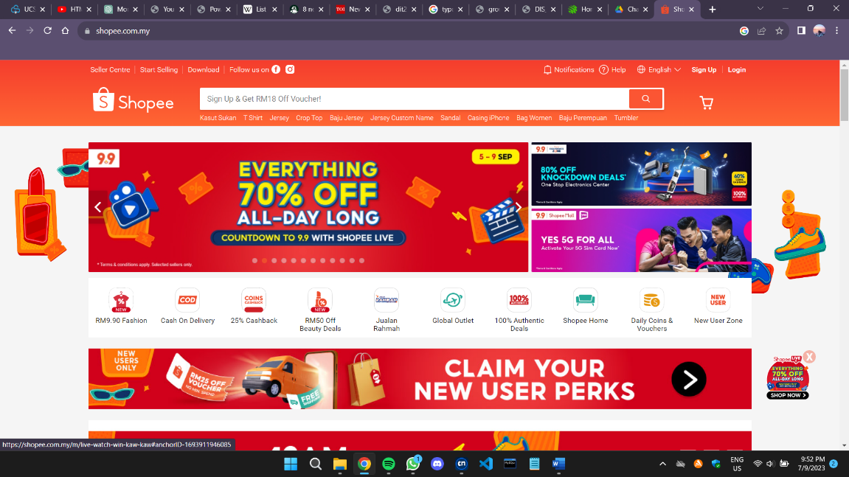

Figure 1.1 Shopee Home Page

Shopee is a renowned e-commerce platform recognized for its wide variety of products and frequent promotional events. These promotional events enable users to access discounts, hence allowing customers to obtain better value for their money when shopping.

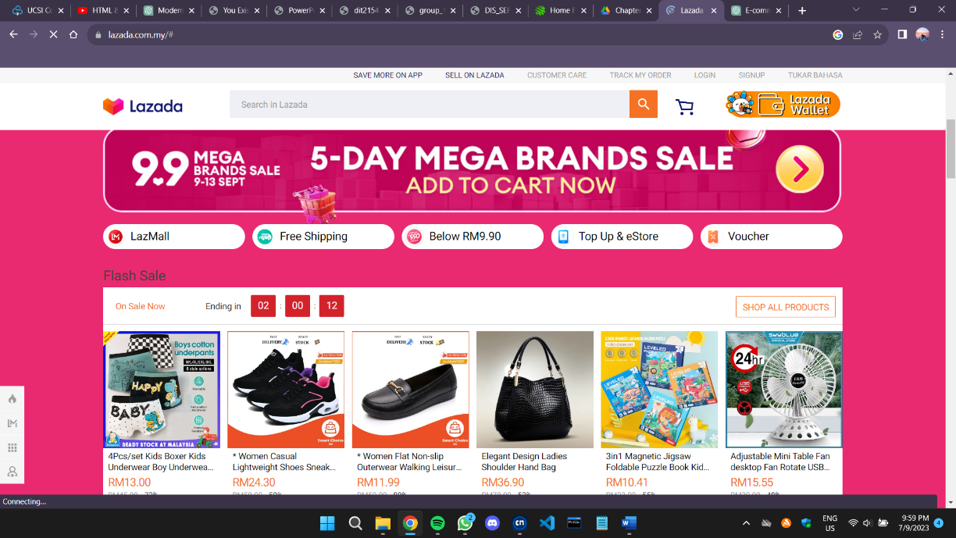**Lazada**

Figure 1.2 Lazada Home Page

Lazada is also another major e-commerce company where it provides various selection of products for users to choose from and it also ensures convenience with multiple payments methods.

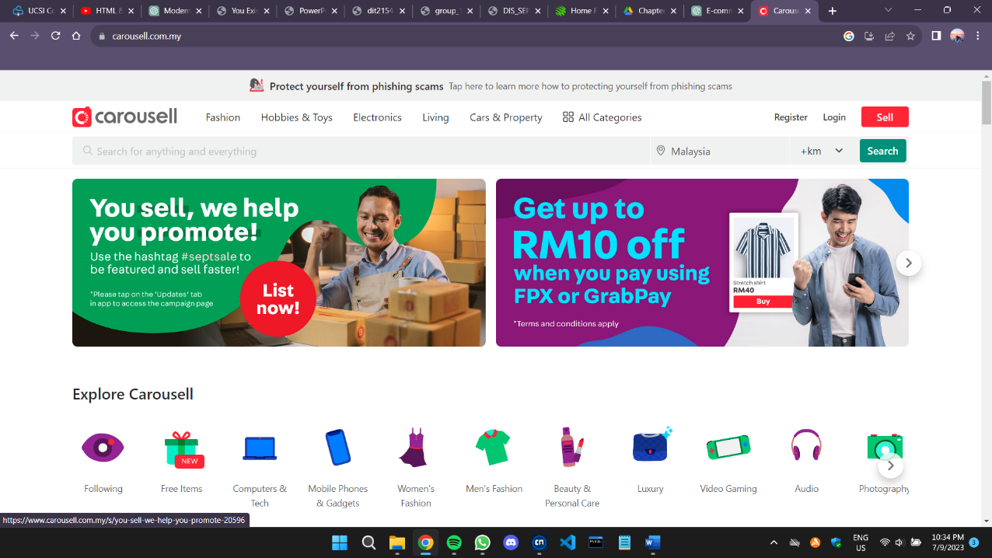**Carousell**

Figure 1.3 Carousell Home Page

Carousell is a marketplace which allows a large number of sellers to sell unused products or second-hand items on its website. While it does provide various payment options, including in-app transactions, it mainly focuses on face-to-face transactions, where both the seller and buyer meet at an agreed location to complete the payment and exchange.

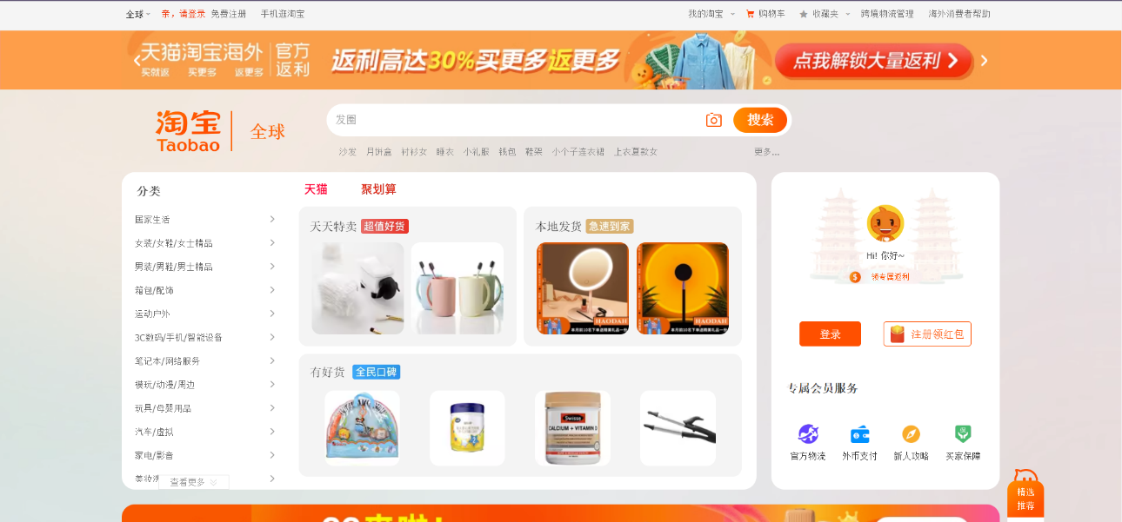**Taobao**

Figure 1.4 Taobao Home Page

Taobao is China’s leading online marketplace, offering a variety of products at competitive prices. It is well known for its expansive seller network, features like live streaming, and a diverse mix of domestic and international brands. However, it’s main focus is on the Chinese consumers.

**FUNCTIONS**

|  |  |  |
| --- | --- | --- |
| **Name** | **Functions** | **Descriptions** |
| Wong Reyao | * Contact Us * Home page * Language and region * Product (Books and Pens) | Contact Us: Allows customers to be able to contact our business when they have enquiries.  Home page: The home page serves as the initial point of interaction for customers visiting our website, shaping their first impression.  Language and region: Allow users to change between languages so that they understand the content of a webpage. |
| Caleb Chan Kyle | * Background & Introduction * Login & Registration * Search and Filter * Product (Clothing) | Background & Introduction: To provide information about our organization.  Login & Registration:  Allows users to be able to log in and use their own personal account.  Search and filter: This feature enables users to narrow down product listings to only display items that fits their specific requirements or needs. |
| Liew Zhi Jian | * Wishlist * Payment Option * User Accounts * Product (Electronic Devices) | Wishlist: This feature allows users to be able to stay updated on products they desire to purchase.  Payment Option: Allows users to select their preferred payment methods when purchasing products.  User Accounts: Enables users to view and update their own personal information. |
| Kok Zhen Hui | * Cart Page * Products (Exercise Equipment) and Category * Customer Services | Cart Page: Enables user to view the products saved in the shopping cart.  Customer Services: Allows customers to engage in live chat with customer service representatives when they encounter issues or have questions. |
| Chung Shu Wen | * Promotion and Flash deal * Delivery Status * Product (Daily Products) | Promotion and Flash deal: This features the current on-going promotions and limited-time offers.  Settings: Allows user to customize their experience when using our website.  Delivery Status: This feature provides users with the current status and real-time information of their ordered product. |

**TARGET AUDIENCE**

Shopee's main market is online shoppers who buy a range of goods, including electronics, clothing, cosmetics, home goods, and more. Convenience, a large product range, and affordable costs are frequently sought after by this demographic. Due to its varied product offers and services, Shopee, like many e-commerce platforms, appeals to a wide spectrum of target customers. According on the market and area, Shopee's precise target markets might differ, however some typical target groups include:

**Millennials and Generation Z consumers:**

Shopee's user-friendly mobile app and website design, as well as its social commerce elements, appeal to younger customers who are tech-savvy and at ease with online buying. New trends in internet buying are frequently embraced by these age groups first.

**Value Shoppers:**

Shopee is well-known for its low pricing, discounts, and promotions. It draws budget-conscious customers searching for bargains, discounts, and money-saving opportunities.

**Small Business Owners and Entrepreneurs:**

Shopee gives small companies and entrepreneurs a platform to reach a larger client base. It provides tools and resources to assist businesses in establishing online storefronts and managing their e-commerce activities.

**Fashion Enthusiasts:**   
Shopee has a large selection of fashion and apparel goods, making it a popular destination for those shopping for stylish clothing, accessories, and beauty products.

**Families and Parents:**

Shopee's selection of children's products, toys, baby gear, and home supplies makes it an enticing alternative for parents and families searching for easy purchasing options.

**Gamers & Hobbyists:**

Because Shopee frequently holds sales events for gaming consoles, peripherals, and hobby-related products, it is a popular destination for gamers and hobbyists.

**Local Shoppers:**

Shopee's emphasis on local marketplaces and sellers appeals to customers who like to support local companies and buy regional items.

Shopee's marketplace concept enables sellers and merchants to list their items on the site, making it a target for businesses wishing to increase their online presence and reach a wide client base. It frequently advertises the latest gadgets, electronics, and tech-related items. This attracts tech-savvy customers who want to remain up to speed on the newest technological advancements. It’s target audience is large and diversified, and the platform's marketing techniques and services are always evolving to meet the particular tastes and demands of these many client categories. Shopee's agility helps it to remain competitive and relevant in the fast-paced e-commerce business.

**MEMBER INTRODUCTION**



**Hello~ My name is Wong Re Yao. I am 20 years old this year.   
You can call me by my nickname Yao ("0w0")b**



**Ola! I'm Caleb**

**I'm currently going through my Second Semester and**

**this is Our Web Design**

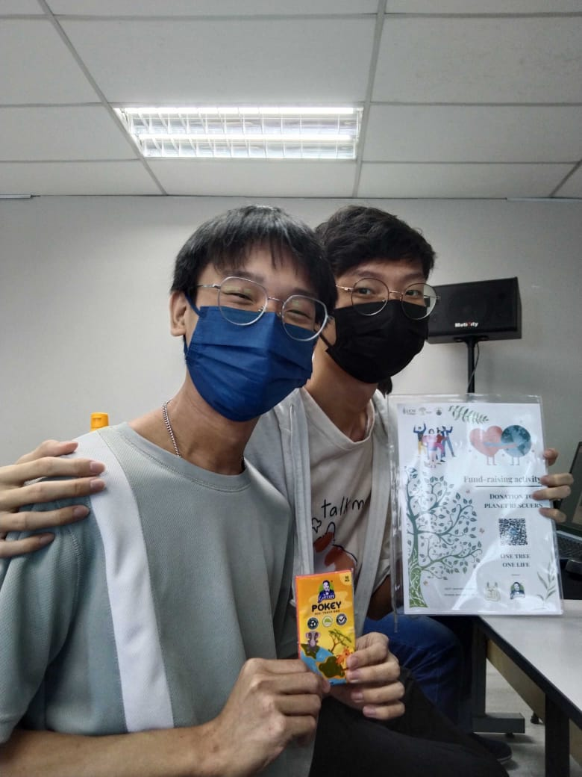

**Ola! I'm Zhi Jian**

**(The one on the left of the picture)**

**I'm currently going through my Third Semester and**

**this is Our Web Design**

**I got my description inspiration**

**From my friend Caleb :)**



**My name is Kok Zhen Hui**

**and I’m studying in**

**Diploma in Information Systems.**

**I’m 19 years old and this is my third semester in UCSI COLLEGE**





**My name is Chung Shu Wen**

**and I'm studying in Diploma in Information Systems.**

**I'm staying in Cheras.**

**REFERENCES**

*Leading Online Shopping Platform In Southeast Asia & Taiwan | Shopee*. (n.d.). Shopee. <https://shopee.com/>

*Sea Group*. (n.d.). Sea Group. <https://www.seagroup.com/investor/home>

Tech in Asia. (n.d.). *Tech in Asia - Connecting Asia’s startup ecosystem*. <https://www.techinasia.com/sea-technology-company-accidentally-game-developer>

*Target markets of Shopee and prudential.docx* <https://www.coursehero.com/file/71701816/Target-markets-of-Shopee-and-Prudentialdocx/>

**Part 2**

**TABLE OF CONTENT**

|  |  |
| --- | --- |
| **Page** | **Content** |
| 1 | Cover Page |
| 2 | Table of Content |
| 3 | Use Case Diagram |
| 4 - 9 | Layout |

1. Present your project scope and use cases (functions) in a use case diagram.

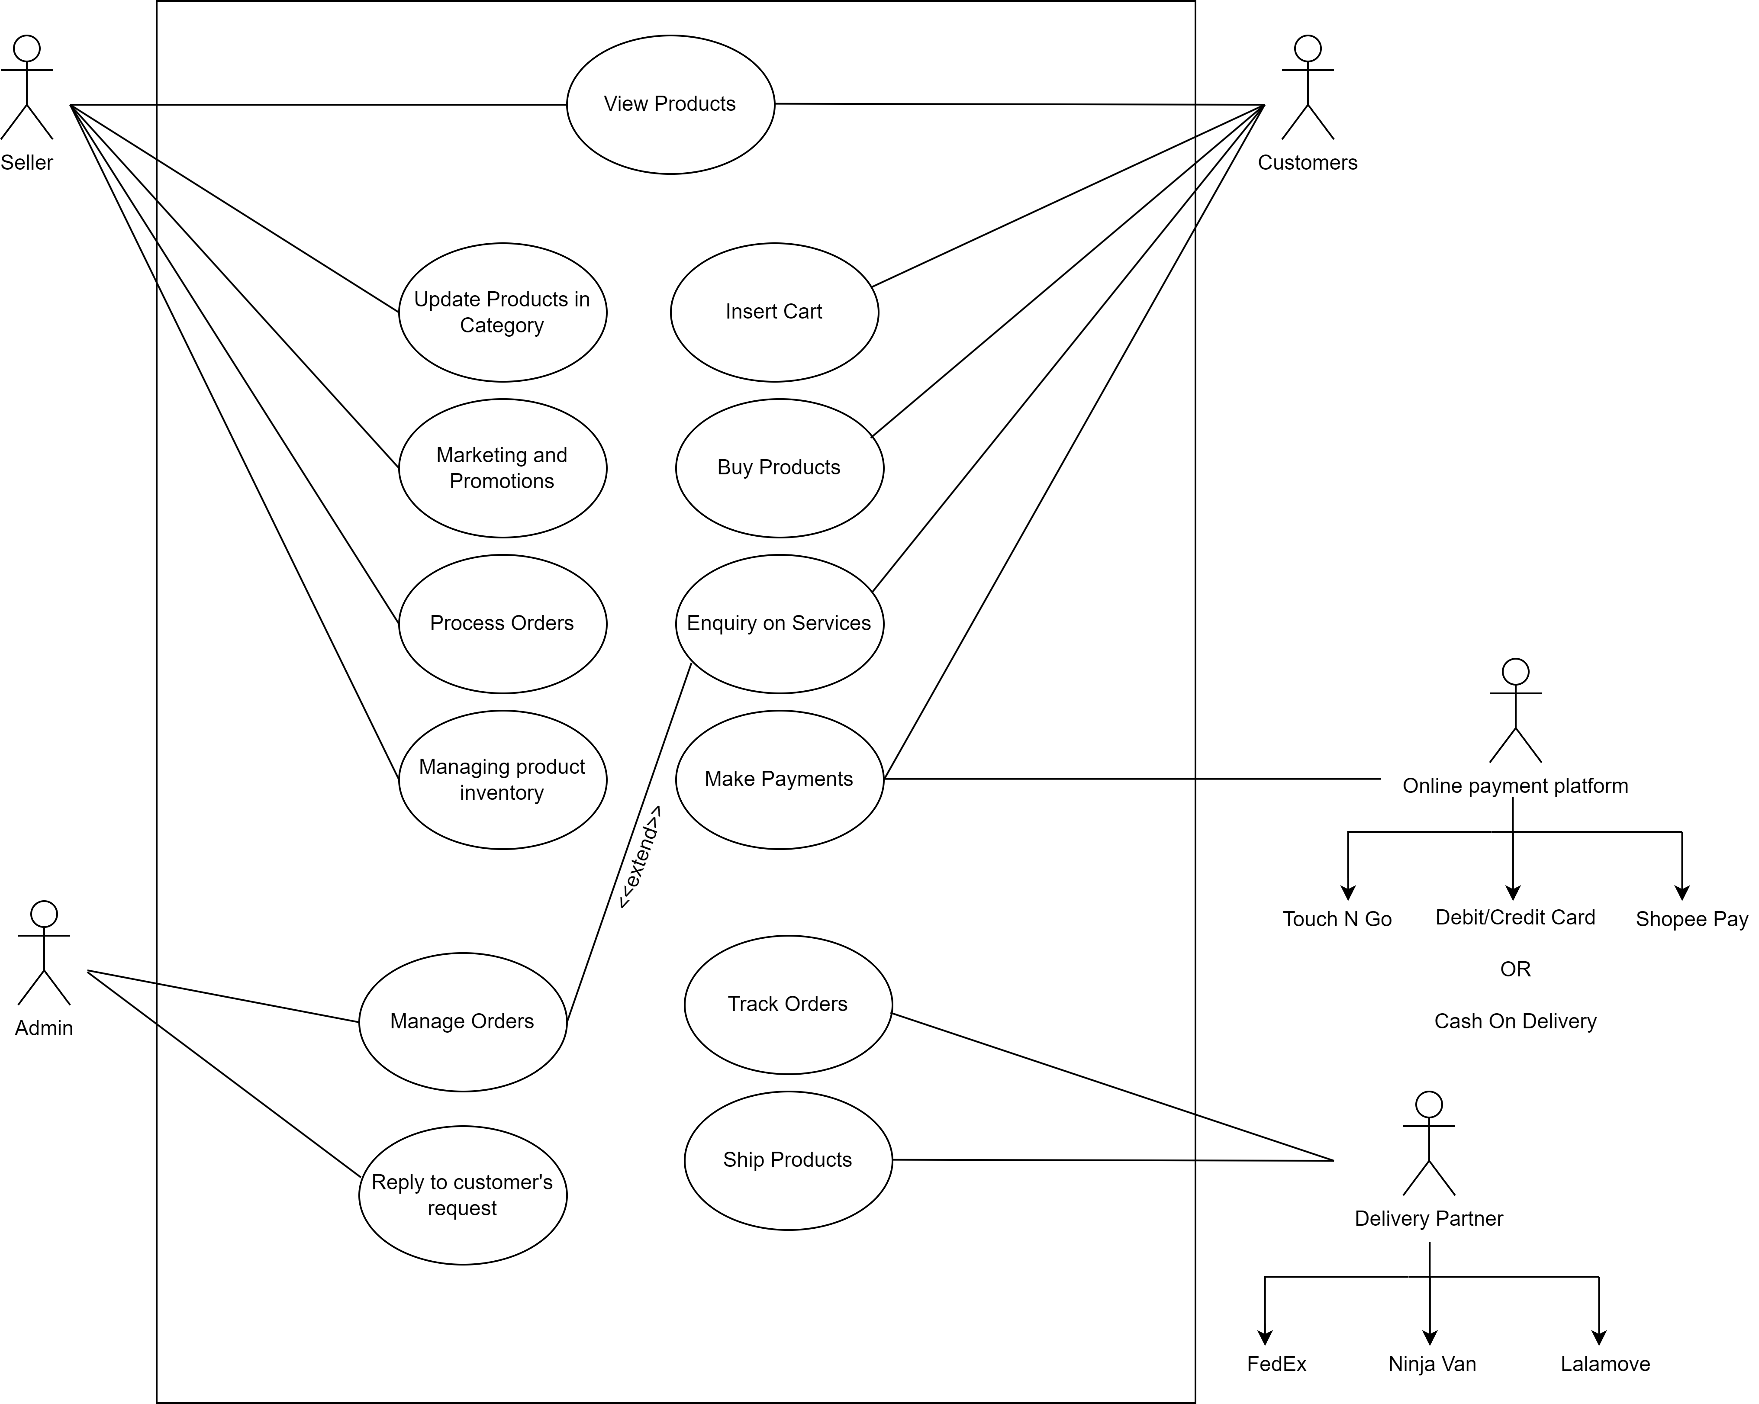

2. Scratch the layout of your Web application using any software tools / hand drawn and write a brief description for each layout.

1. Shopping Cart Page

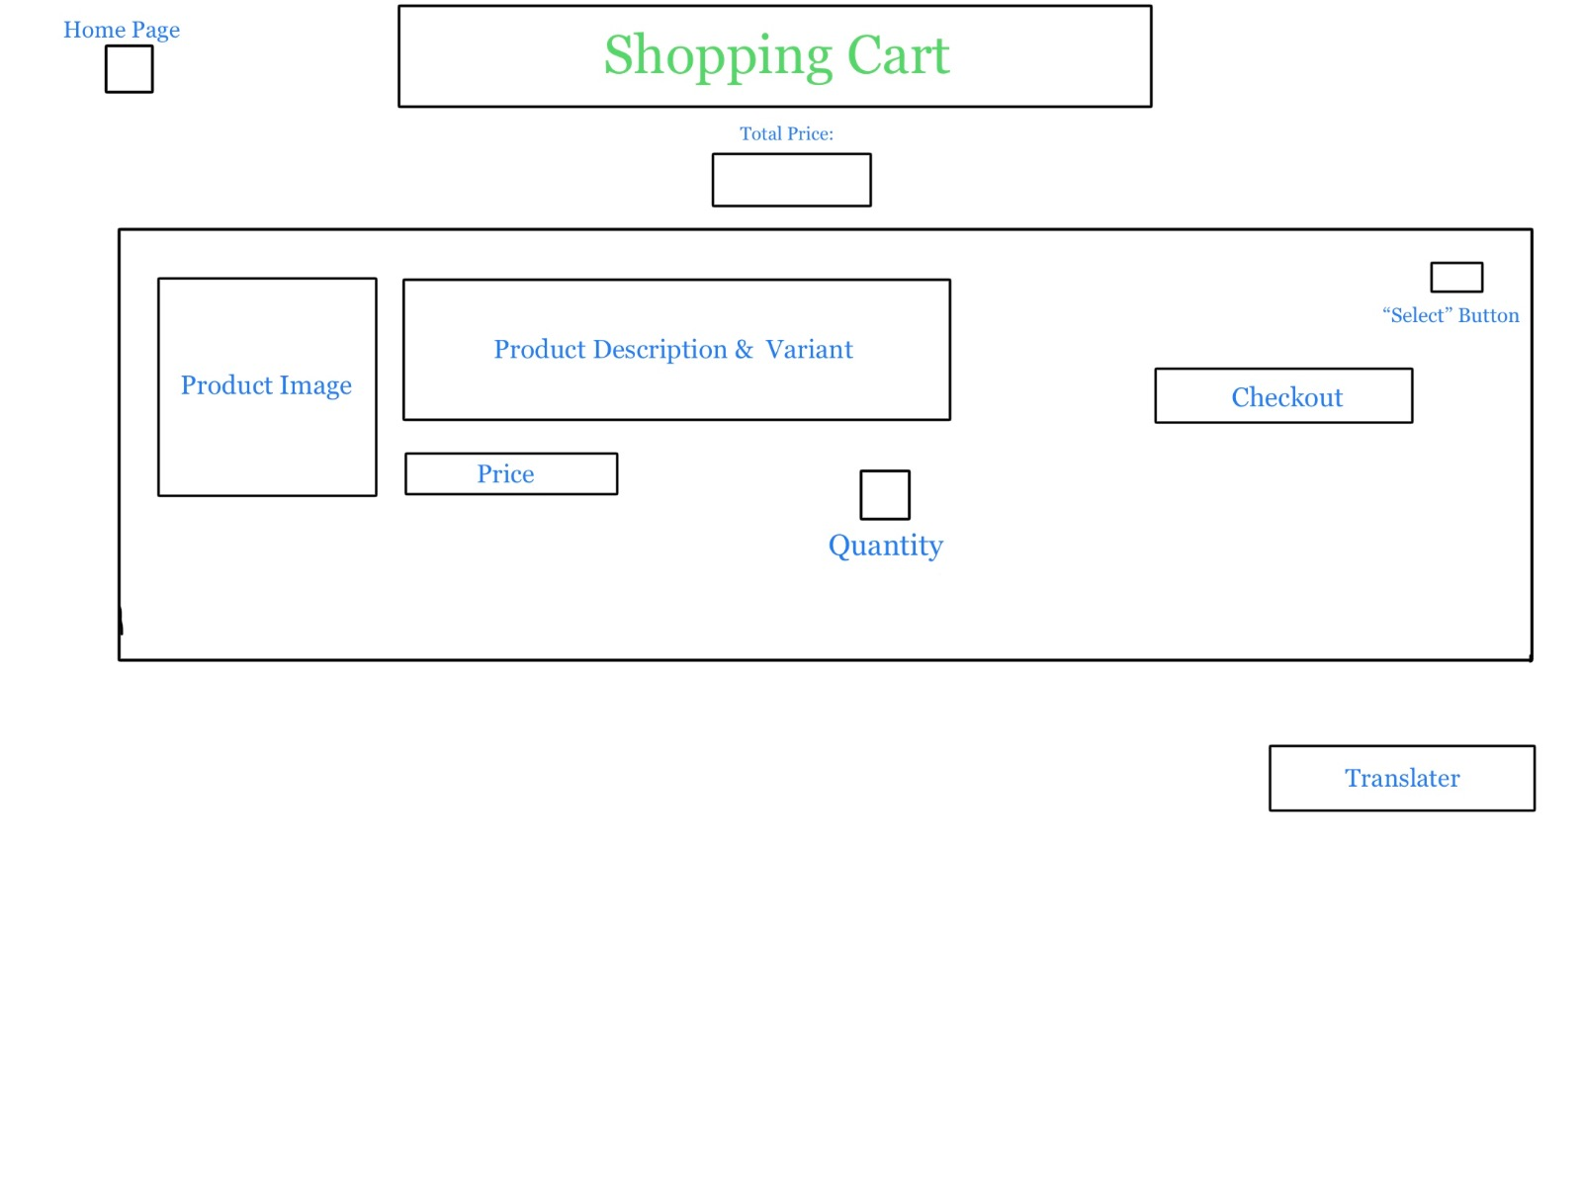

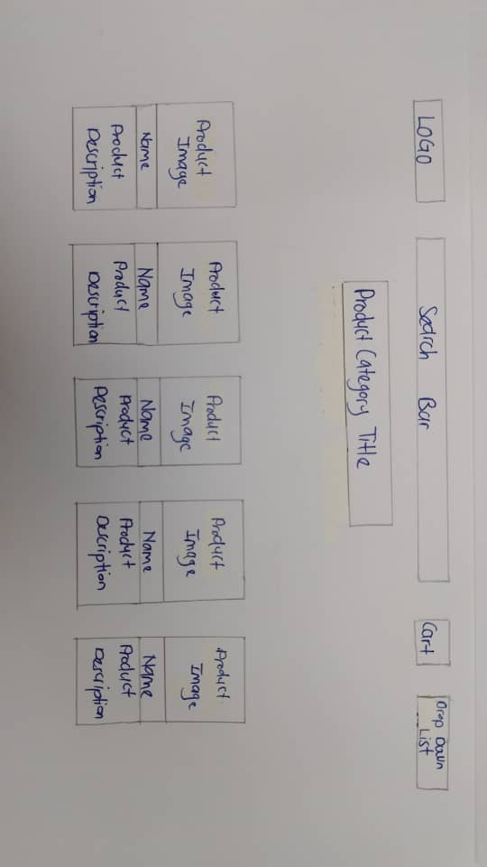The Shopping cart functions by allowing users to view, manage and update from their online shopping list, providing a convenient and efficient way to review, modify and ultimately purchase products from an e-commerce platform.

1. Products Category Page

This webpage specifically shows products which are only related to topic selected.

1. Customer services page

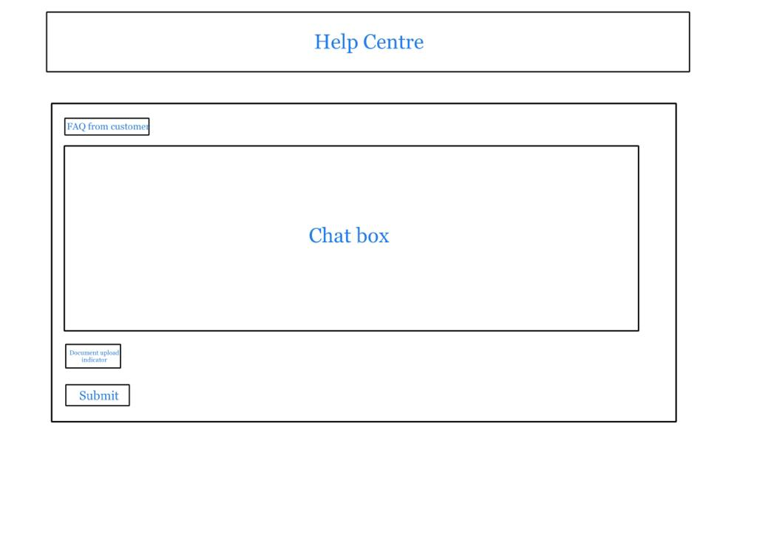

The customer’s services page is specifically designed to assist users when they meet any difficulties or problems when using the website, and hence helping them to solve their problems.

1. Promotion and flash deal page

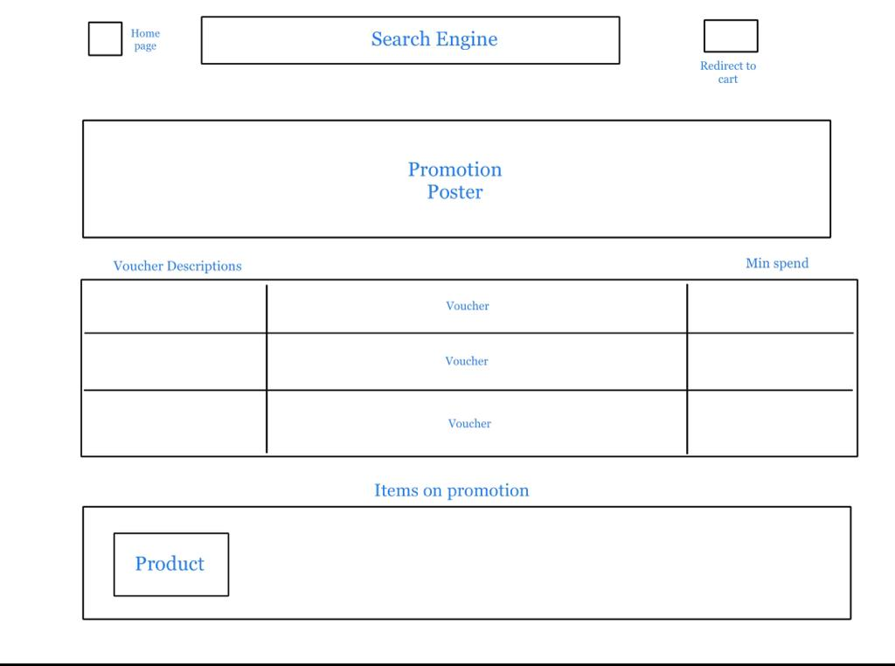

This main purpose of this webpage is to effectively inform and attract the market specific products, services, or offers to a target audience, encouraging them to take desired actions such as making a purchase, signing up, or engaging with the brand.

1. Delivery status page

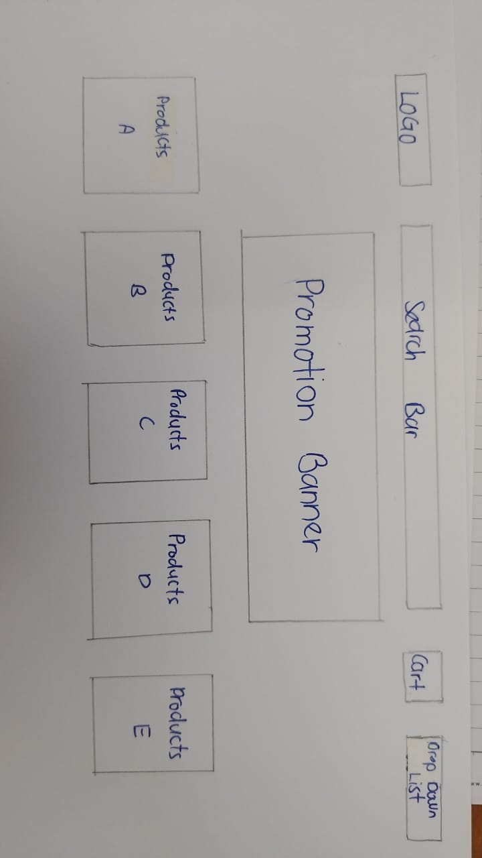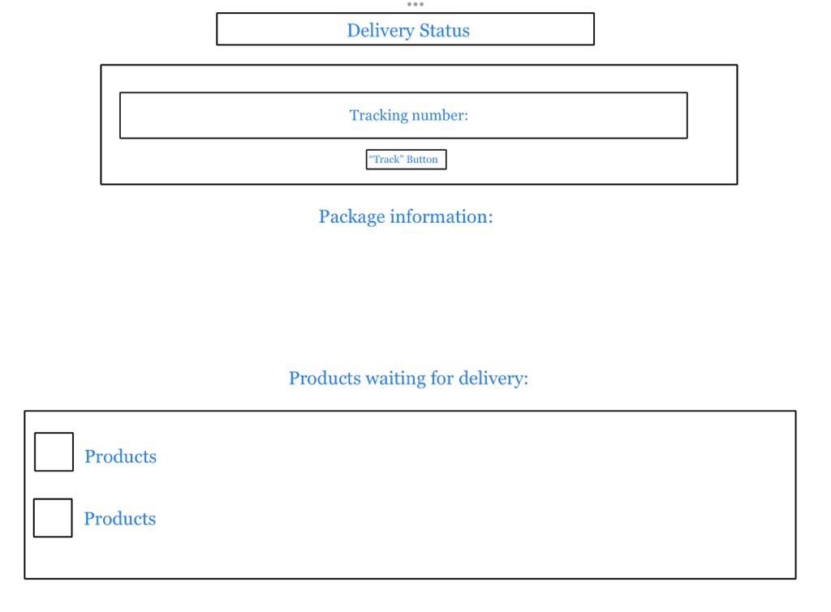

Delivery Status page is created to provide real-time information about the whereabout location of the ordered products.

1. Home Page

This page is the first interface which users see, where featured or suggested products are shown.

1. 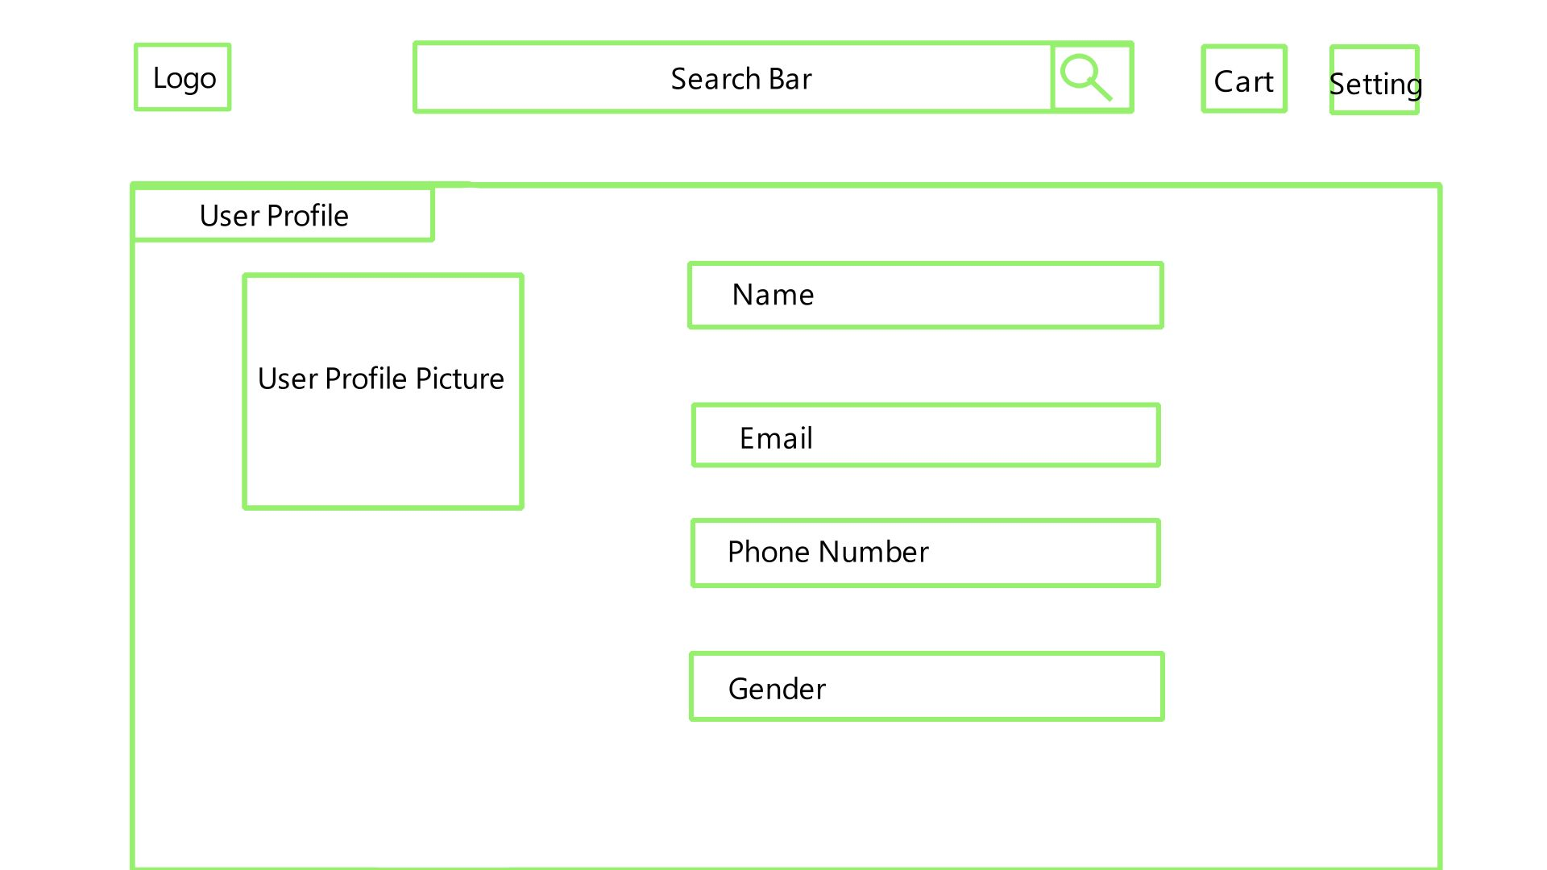User Profile

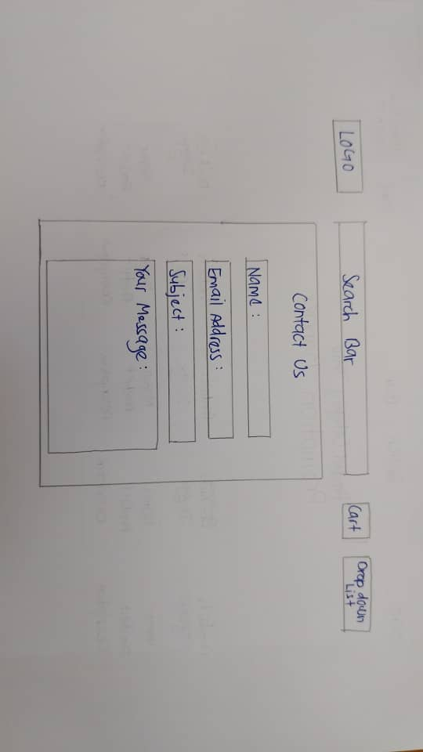

This webpage shows the personal information of the user.

1. Contact Us Page

This webpage allows users to reach out to the support team if they have any inquiries about the website.

1. 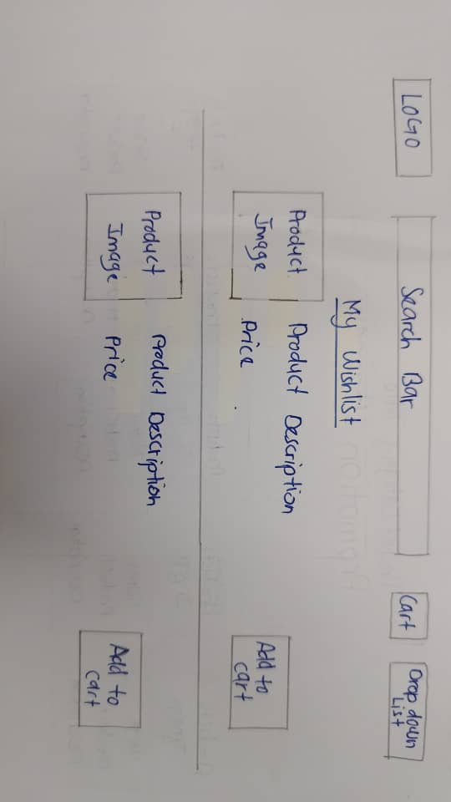Wishlist

This webpage allows user to save products that they are interested in at particular storage so that they can view it back whenever they want.

1. Login Page

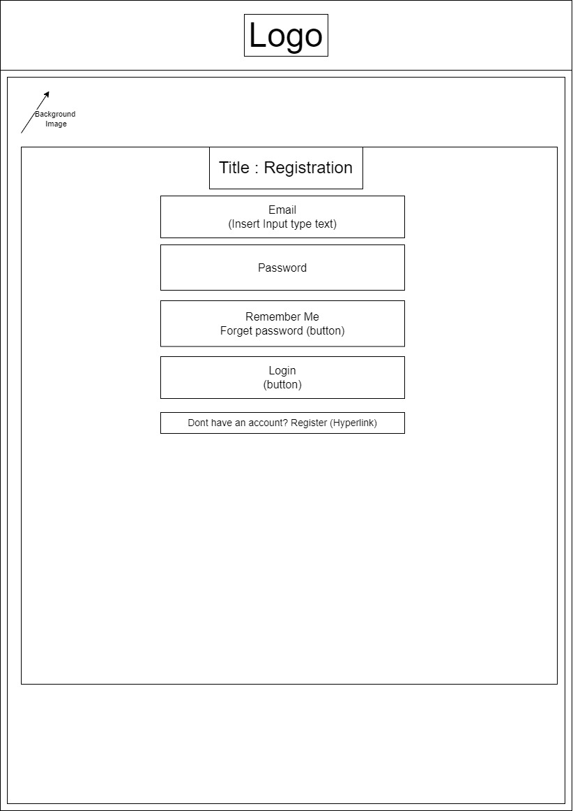

Login Page is where the user inputs the required fields so that they could access to their own personal account.

1. Registration Page

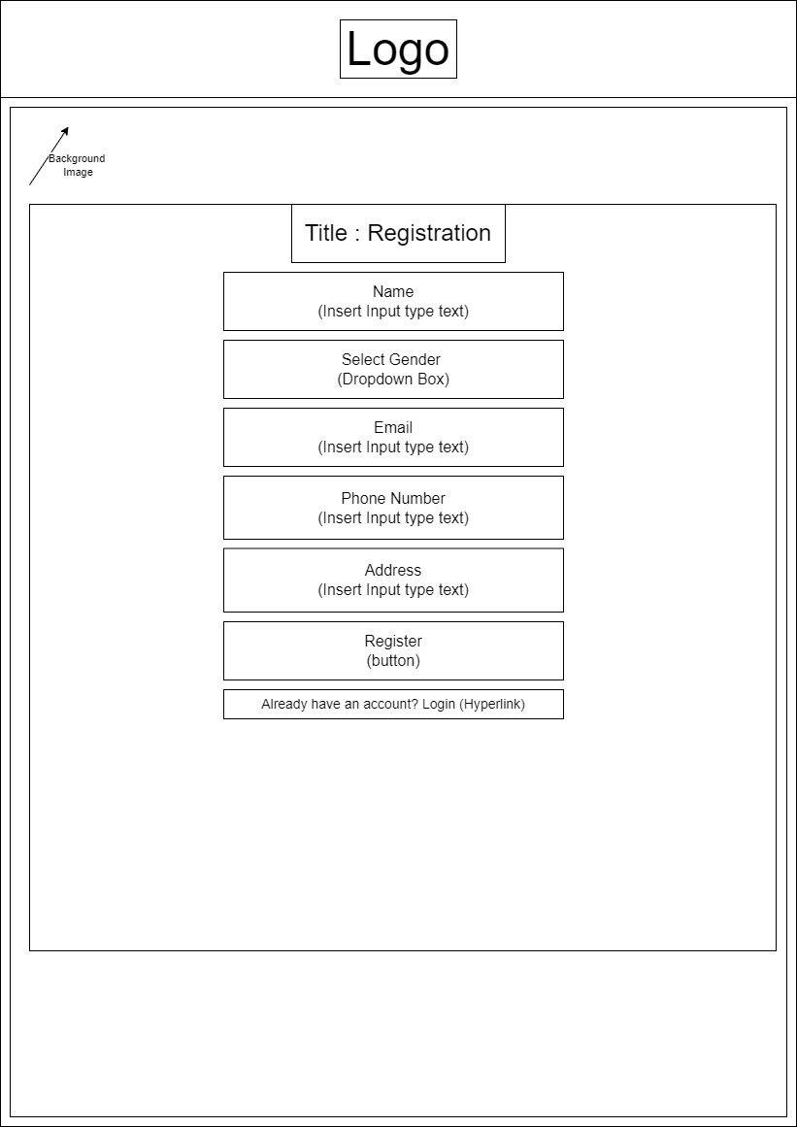

Registration Page is made for users which do not have a personal account yet. Users will have to sign up at this page, by providing personal details about themselves.

1. Background & Introduction Page

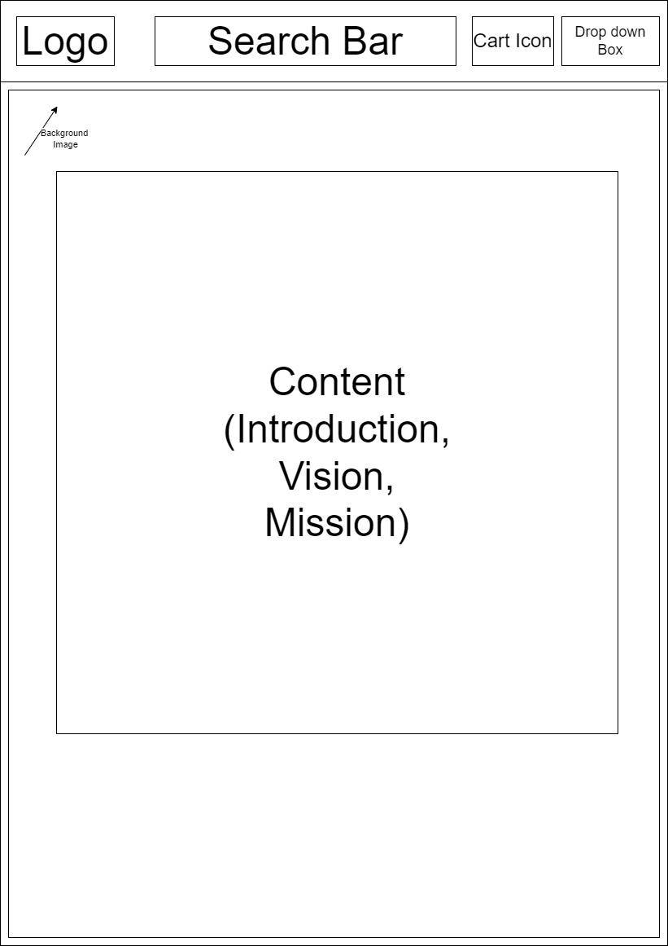

Background Page is made to allow users to have a deeper understanding of the background of our company.

1. Search Bar and Search Bar functions

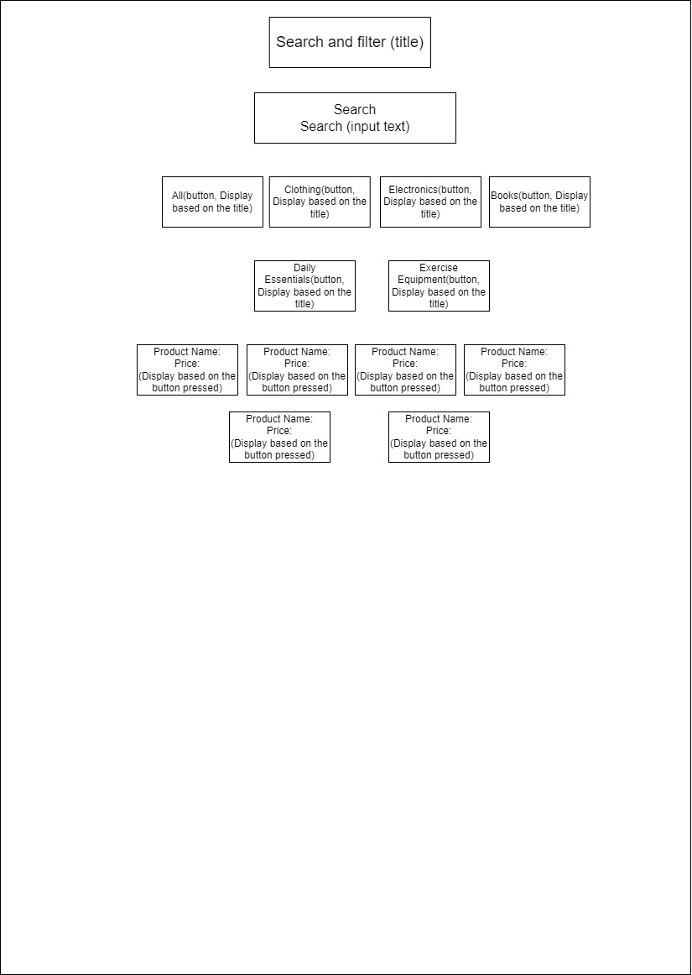

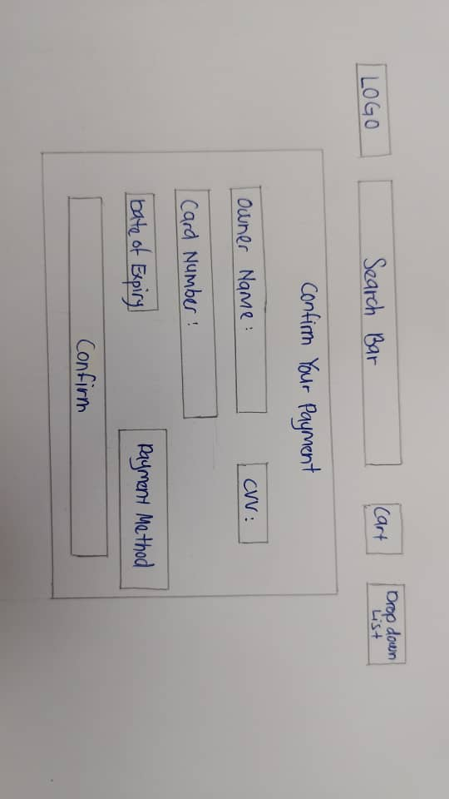Search Bar features allows users to narrow down the product list based on their needs and requirements. For example, if the user click on the clothing, it will direct the user to page which includes only clothing products.

1. Payment Option

This page is located at the payment page where the user makes the payment. The payment option feature is made available for users to choose between their debit, credit cards or cash on delivery for payment for a particular product.

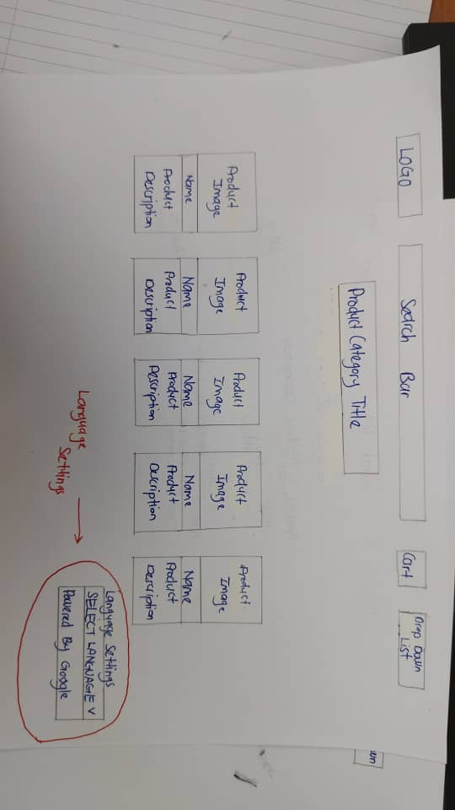m) Language Settings

Allow users to change to their preferred language based on their region so that they can understand the content page better.

**Part 3**

1. Shopping Cart Page

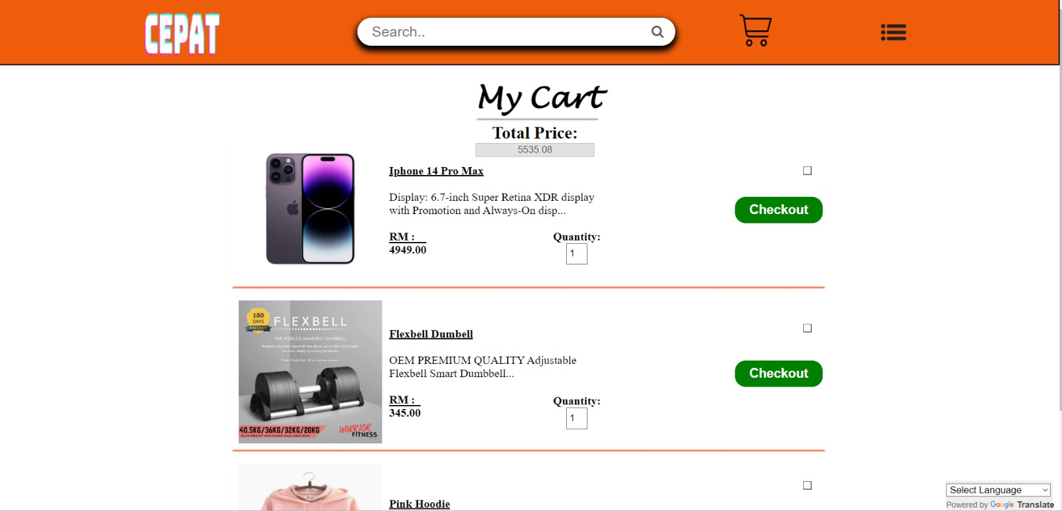

The Shopping Cart Page is a virtual shopping cart, where users are able to review and manage the items they've selected for purchase before checking out. For example, in this page the user has added Iphone 14 Pro Max, Flexbell Dumbell and etc based on the image shown above.

1. 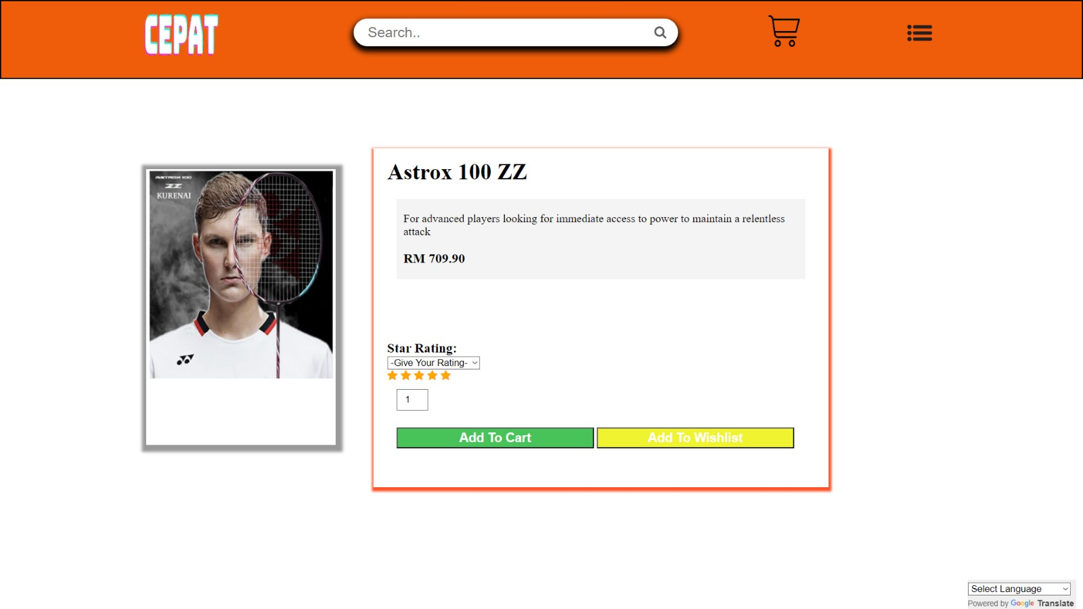Product Category Page (Example: Exercise Equipment Category)

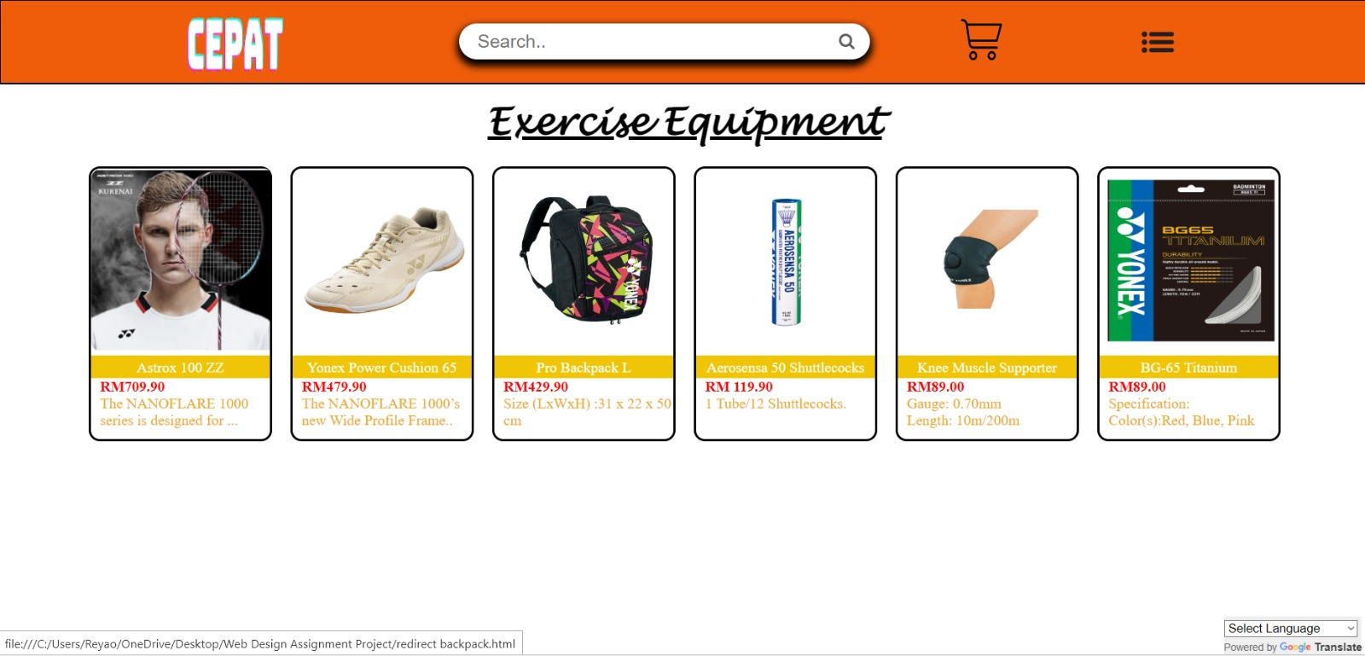

Based on the webpage on the left, the webpage shows products which is specifically designed for exercise equipment related products. If users wish to find exercise equipment related products, this should be the page to find the related items. Moving on to the image on the right, we can see that a more in-depth product review will be provided when one of the product is clicked on.

1. Customer Service Page

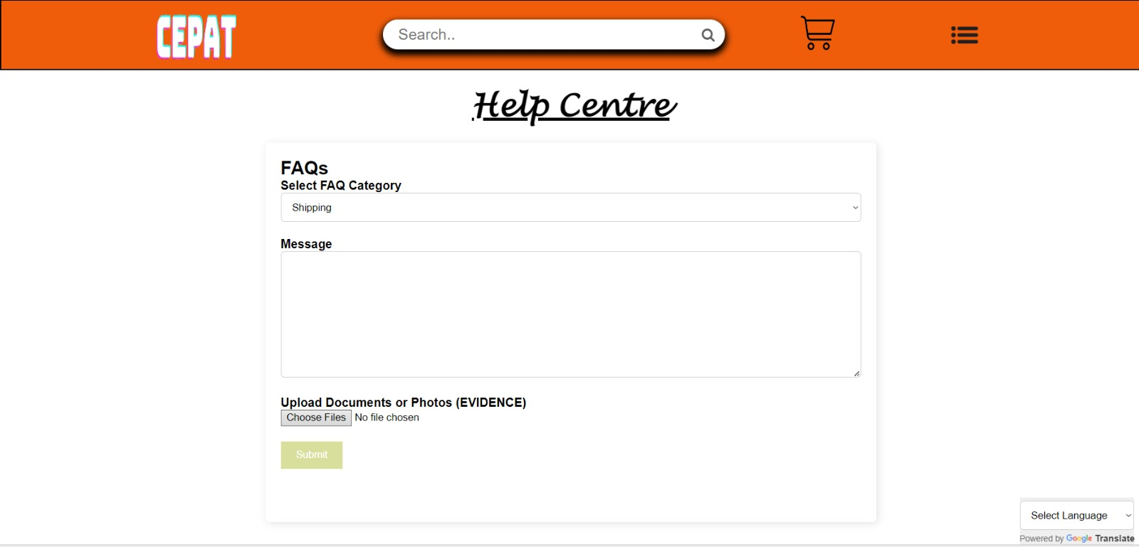

Customer Service Page, also known as Help centre is a dedicated feature provided to all user’s questions and concerns, providing support, guidance, and answers to user’s inquiries.

1. Promotion and Flash Deal Page

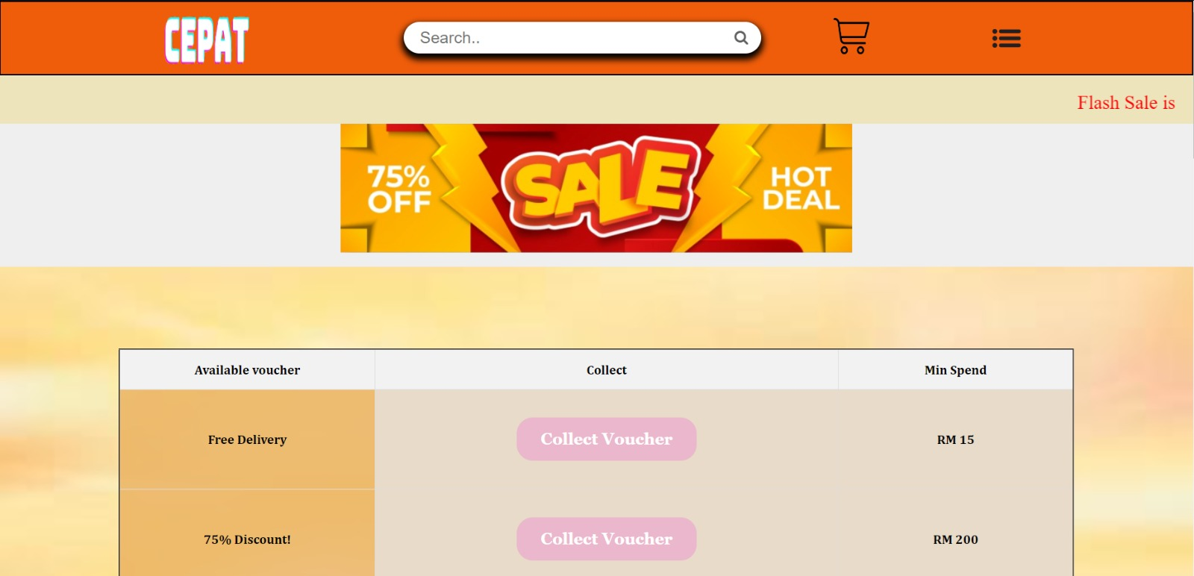

Based on the figures above, on the left we could see that it’s a page where users can collect vouchers and used them when checking out. On the right we could see that those products are on sale which means that is the best time to purchase the particular product.

1. Delivery Status Page

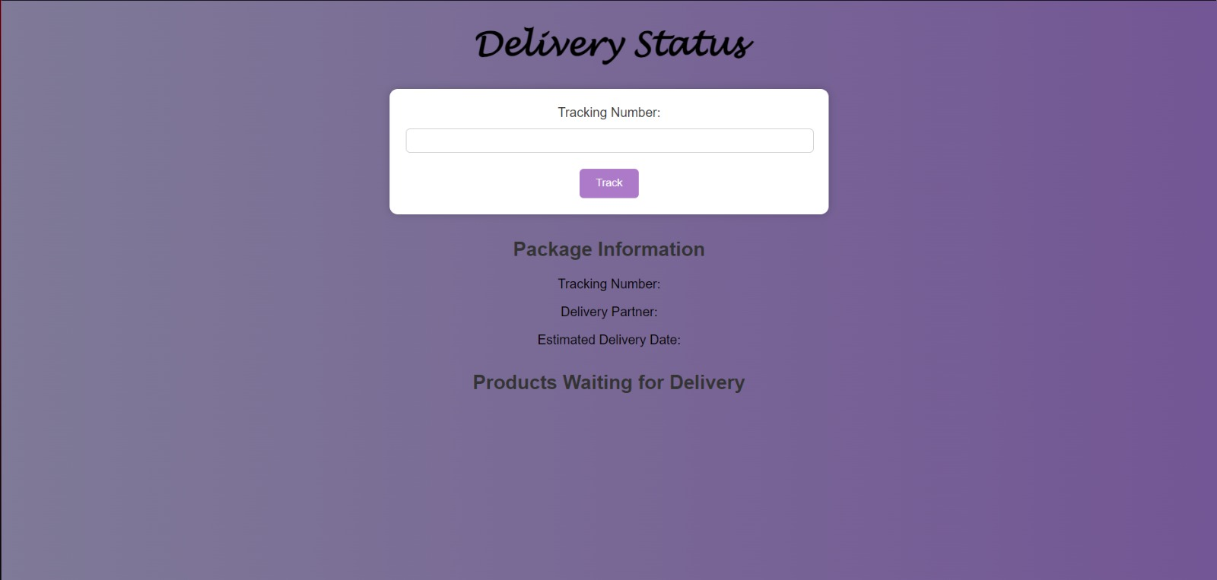

User’s are able to check the location or whereabout and delivery time of their ordered package by using the Delivery Status Page shown above simply by inserting the tracking number provided.

1. Home Page

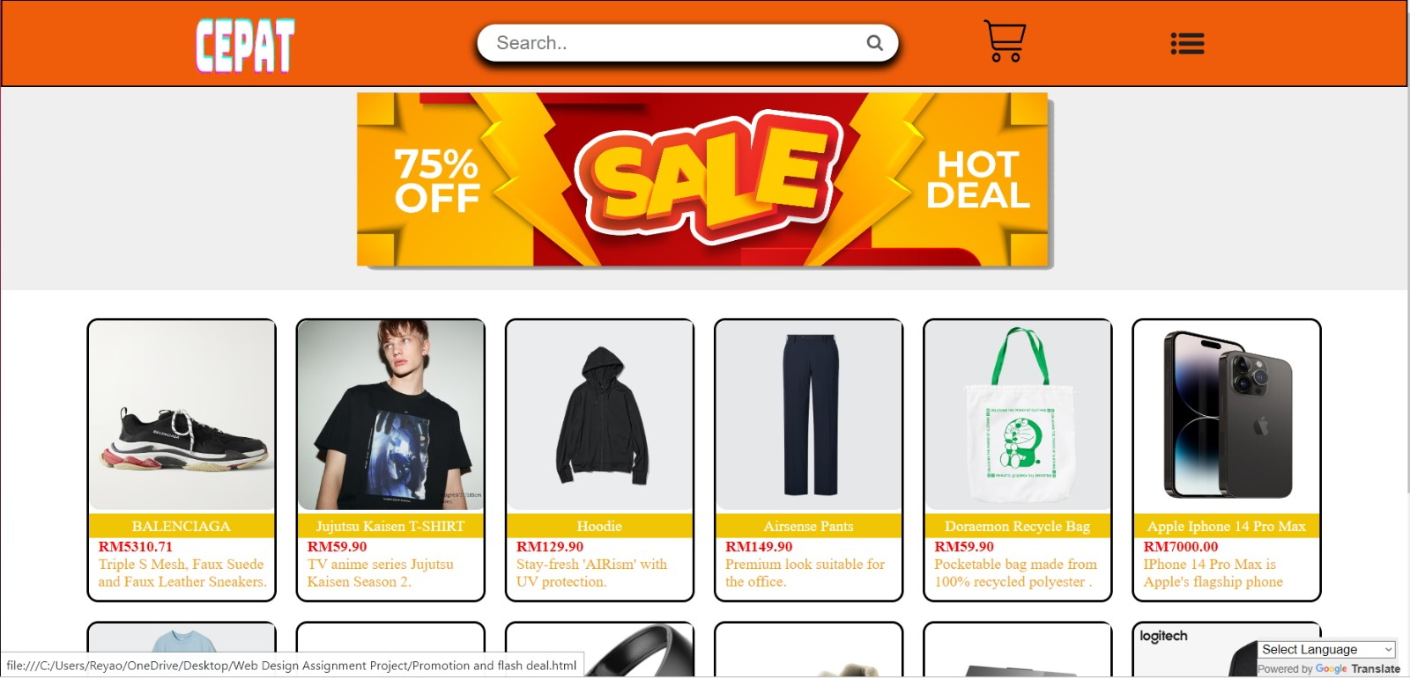

The Home Page acts like a central hub of the website, offering quick access to featured products, promotions, and navigation to various sections of the site.

1. User Profile

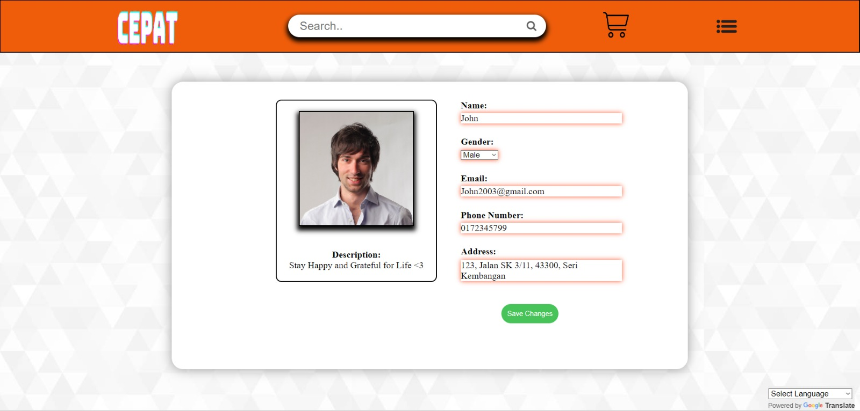

As you can see in this webpage, it shows the person “John” personal details based on what he entered when registering with the e-commerce platform.

1. Contact Us Page

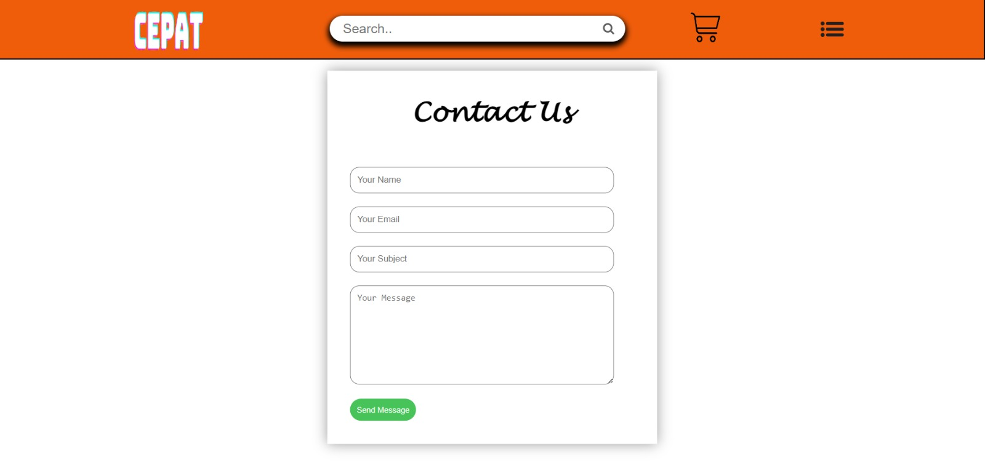

The Contact Us page is like a digital gateway that provides a means for anyone, from customers to potential partners, to connect with the corporation by providing their name, email address, subject and their message.

1. Wishlist

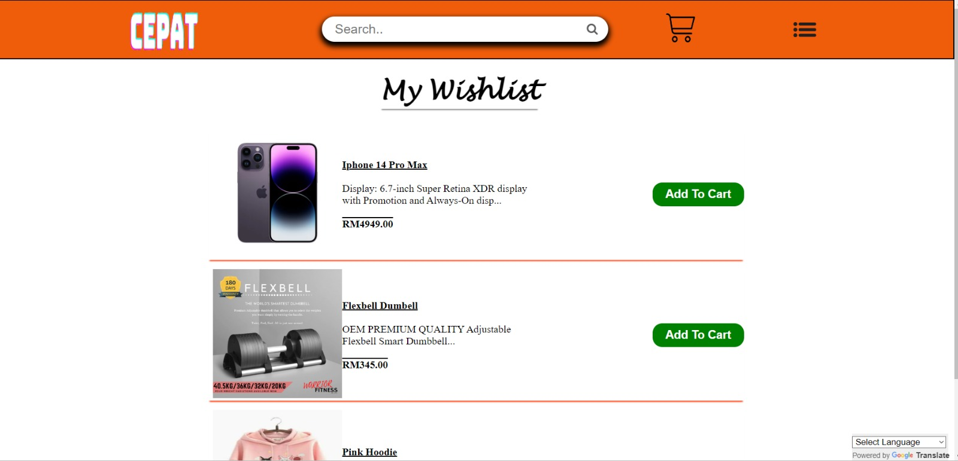

Wishlist is like a virtual shopping dream board, where user can save and organize products they love, making it easy to revisit, compare, and prioritize their most-wanted items for future purchases.

1. Login Page

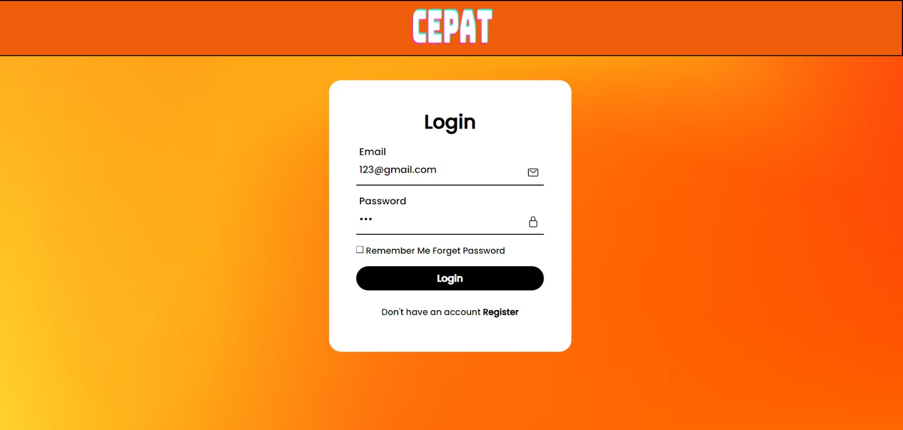

This webpage allows users to access their very own personal account, simply by entering the required credentials such as email and password.

1. 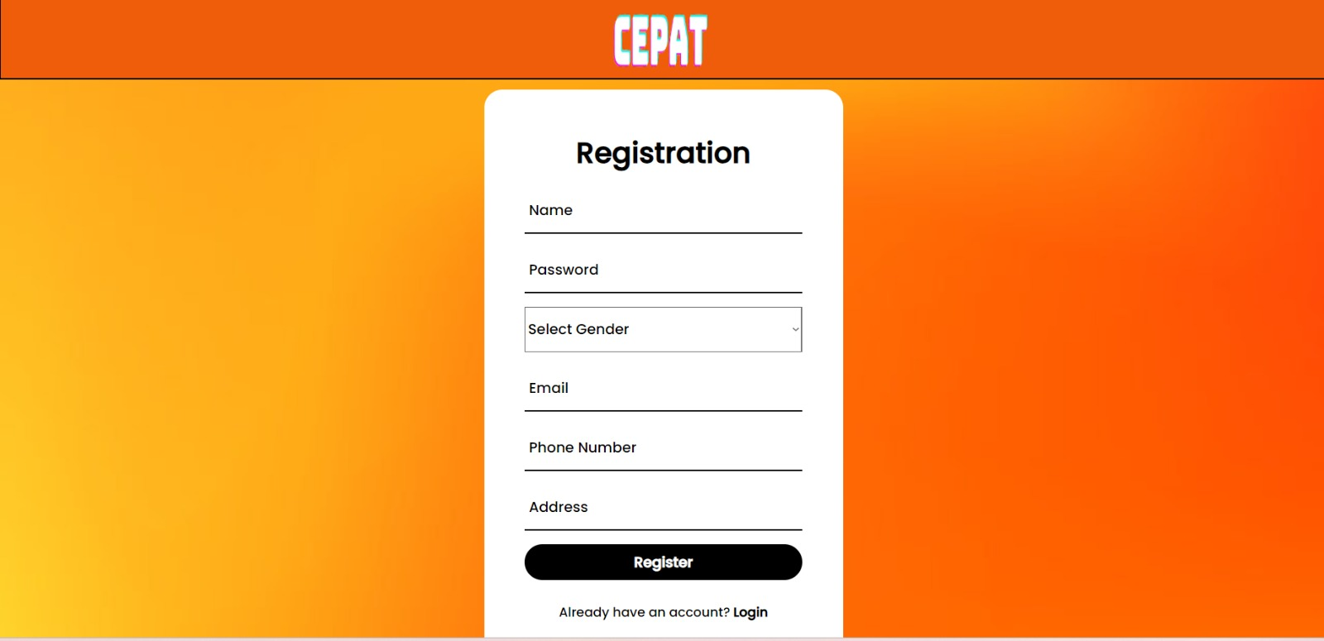Registration Page

The Registration Page is designed to help user’s to create an account by asking user’s to fill in the required fields.

1. Background and Introduction Page

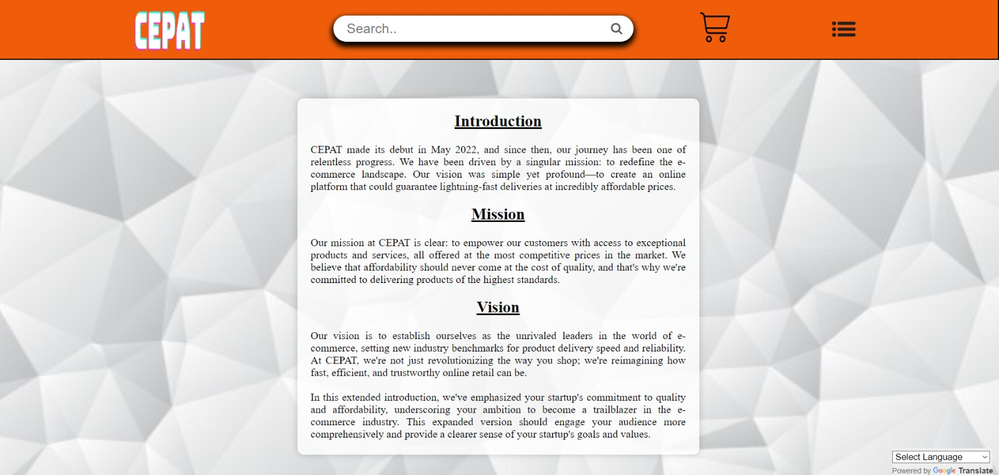

This webpage is created to let users to learn about the company's history, mission, and values, providing an insight into the organization's background.

1. Search Bar

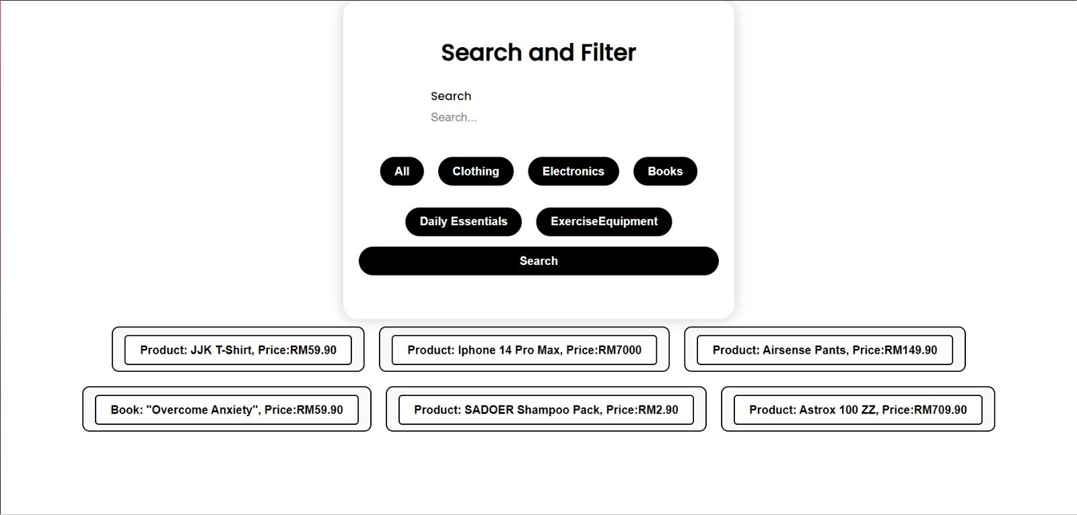

This function is created to make the user’s life easier by entering keywords or choosing specific product category, making it a more efficient and effective way to search for products.

n) Payment Options

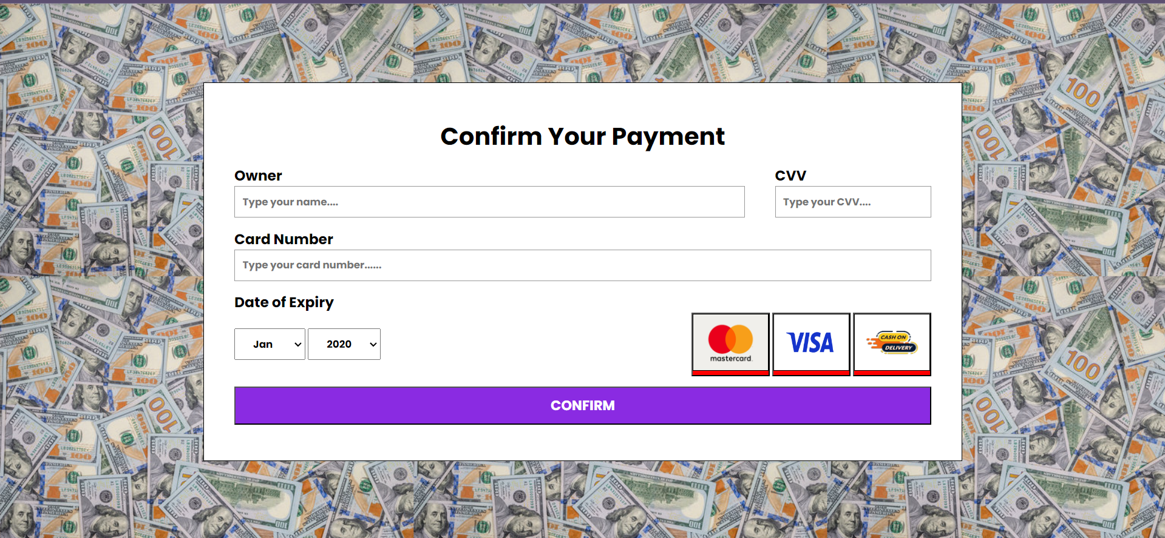

This page allows users to select their preferred payment method when checking out. When pressed on the confirmation button, order will be arranged for delivery to user’s doorstep.

1. Language Settings

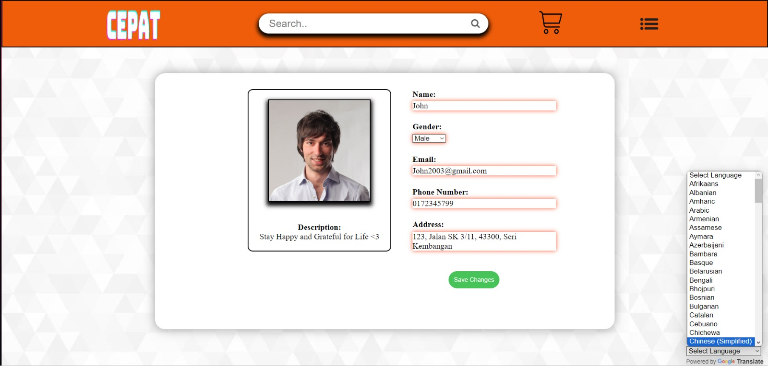

As you can see on the bottom right of the image shown above, we can see a scrollable drop-down list which is actually the type of languages available for users to choose from based on their region. Ensuring that the content and communication are in a language the users are able to understand and are comfortable with.

**MEMBERS**



**Wong Re Yao**

**2023000072**



**Caleb Chan Kyle 2023000029**



**Liew Zhi Jian 2022000038**



**Kok Zhen Hui**

**2022000499**





**Chung Shu Wen**

**2022000477**